Practical No. 19
Aim : 5) Write a Jtree program to show root directory and its subFolders of your system

Name : Danish Altaf Solkar | Class : CO - B
Enrolment no. : 24111590805 | Batch : 2

Code :-
import javax.swing.*;
import javax.swing.tree.DefaultMutableTreeNode;
import java.io.File;

public class JTreeExample {
public static void main(String[] args) {
JFrame frame = new JFrame("JTree Example");
DefaultMutableTreeNode root = new DefaultMutableTreeNode("Root Directory");
File[] roots = File.listRoots();

for (File rootDir : roots) {
DefaultMutableTreeNode rootNode = new
DefaultMutableTreeNode(rootDir.getAbsolutePath());
addSubfolders(rootNode, rootDir);
root.add(rootNode);
}

JTree tree = new JTree(root);
JScrollPane scrollPane = new JScrollPane(tree);
frame.add(scrollPane);
frame.setSize(400, 300);
frame.setDefaultCloseOperation(JFrame.EXIT_ON_CLOSE);
frame.setVisible(true);
}

private static void addSubfolders(DefaultMutableTreeNode node, File file) {
File[] subFiles = file.listFiles();
if (subFiles != null) {
for (File subFile : subFiles) {
DefaultMutableTreeNode subNode = new
DefaultMutableTreeNode(subFile.getName());

node.add(subNode);
if (subFile.isDirectory()) {
addSubfolders(subNode, subFile);
}
}
}
}
}

OUTPUT :-
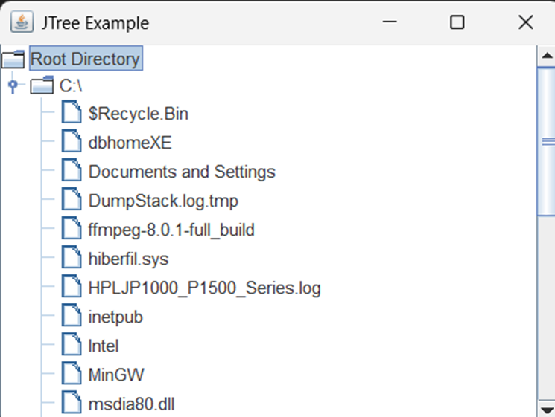

Aim : 6) WAP to create a table of Name of student, percentage and grade of 10 students using JTable

Code :-
import javax.swing.*;
import javax.swing.table.DefaultTableModel;
public class StudentTable {
public static void main(String[] args) {
// Create Frame
JFrame frame = new JFrame("Student Result Table");
frame.setSize(500, 300);
frame.setDefaultCloseOperation(JFrame.EXIT_ON_CLOSE);
// Column Names
String[] columnNames = {"Student Name", "Percentage", "Grade"};
// Data of 10 Students
Object[][] data = {
{"Aisha", 92, "A+"},
{"Rahul", 85, "A"},
{"Sneha", 78, "B+"},
{"Arjun", 88, "A"},
{"Meera", 67, "C"},
{"Zara", 95, "A+"},
{"Kabir", 73, "B"},
{"Ananya", 81, "A"},
{"Rohan", 69, "C+"},
{"Irfan", 90, "A+"}
};
// Create Table Model
DefaultTableModel model = new DefaultTableModel(data, columnNames);
// Create JTable
JTable table = new JTable(model);
// Add ScrollPane
JScrollPane scrollPane = new JScrollPane(table);
frame.add(scrollPane);
frame.setVisible(true);
}
}

OUTPUT :-

